# Objective

To become proficient creating and manipulating arrays and their data.

## Topics: method calling, array creation and manipulation

# Instructions

Look carefully at the examples below. Notice how it looks like this is one continuous object. However, it really is just a series of circles that are drawn according to where the mouse currently is and where the mouse used to be. Let’s create this effect by creating two int arrays that hold 50 elements each at the top of the sketch. One array will remember the x position of an (x,y) coordinate and the other array will keep the y position of the ordered pair. Next, we will need to initialize each array in the **setup()** method to make sure that all values are equal to zero. Our next step will be done in the **draw()** method. Shift all the elements in the array down by one, so we can put our current location into the last spot in the array. Make sure you when you are shifting down that you do not go out of bounds. After you shifted all the elements down, put the current mouse coordinates in the last spot in the array. Finally, we need to loop through the arrays drawing circles at each (x,y) pair. Circles that are farthest away from the mouse (closer to spot 0 in the array) will be smaller and whiter. Circles closer to the end of the array will be black and larger.

# Examples

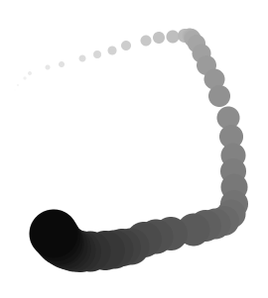

# Challenge

Generate a longer smoke trail and change the color of the trail. Can you get your smoke trail to look like something else?